User Training

Project Manager / Service Manager & Resource Manager (Planners)
Phase 1 – Budget: Project & Service Master Data, Resources, and Costs
Note: Note: This material is confidential and intended for Knauf only. Do not distribute, copy, forward, or disclose without the express consent of Valkeen GmbH.

Contents
- Overview
- Common Tempus Shortcuts
- Tempus Resource Navigation
- Creating a Project
- Project Master Data
- Project vs. Service
- Resource Planning
- Cost Planning
- Bulk Project Allocation Flatgrid
- Reporting Basics

Overview
This guide supports planners at Knauf who work in Tempus Resource in Phase 1 (Budget): Project Manager / Service Manager (PM/SM) and Resource Manager (RM). IT-Controlling, Portfolio Management (PPM), executives, and administrators use overlapping features but follow separate training and governance material.
Screenshots in this document were taken in the Knauf sandbox and may show additional tiles (for example Admin, support, or combined test roles). Your production homescreen shows only the entry points your global role and security group allow.

Why Tempus at Knauf
Main purpose: Provide one online tool where IT colleagues maintain budget, forecast, and actuals per project and service with consistent structures and reporting.
Objectives (Phase 1 alignment):
- Move away from Excel as the primary controlling spreadsheet for these figures.
- Hold budget, forecast, and actuals-related information in one database with shared layouts and reporting across dimensions without manual consolidation.
- Ensure all colleagues work on the same platform with agreed definitions and standards.
Problems Tempus is meant to reduce:
- Poor data quality and many parallel file versions.
- Manual merging of local spreadsheets.
- Single source of truth for planning and cost views.
- Less time on data preparation, more time on analysis.
- Reporting across dimensions (for example cost vs. revenue views, divisions, IT products) for IT stakeholders.

Current vs. Target State (Summary)
Today (simplified):
- Projects: Ideas are collected, estimated (internal effort, consulting, licenses, leasing, managed services, other costs, CAPEX), aligned for capacity, prioritised into an IT portfolio, then iterated with management.
- Services: Budget cash-out by cost category; resource planning in Tempus for services was not the standard process before go-live.
Pain points that motivated the tool:
- Too many Excel versions, missing mandatory fields, divergent prioritisation logic between IT divisions, and incomplete forecast/actual pictures (often only cash-out positions).
Target:
- Easier views of actuals vs. budget and forecast with aggregation (divisions, IT products, portfolios).
- Aligned resource planning and standardised processes with fewer manual adjustments.

Phase 1 vs. Phase 2 (Relevance for This Guide)
| Topic | Phase 1 (Budget) – this guide | Phase 2 (Forecasting / Actuals / Reporting) | | --- | --- | --- | | Focus | Enter required master data, resource and cost information by cost type on projects (and services where Knauf opens this up). | Additional forecast cycles; actuals loaded (for example from SAP); deeper reporting. | | Services – resource planning | Knauf decision for the first year: no resource planning on services in production; focus on project delivery workstreams first. Services remain in scope for master data and cost lines as configured. (Sandbox training may still illustrate service objects for learning.) | Resource planning for services foreseen for later years per Knauf roadmap. | | Historical data | Not migrated in Phase 1. | Active projects and actuals to be loaded per Knauf data strategy. |

Who Does What (High Level)
| Role | Typical Tempus responsibilities in the Knauf model | | --- | --- | | IT product (area) & service manager (PM/SM) | Budgeting and forecasting per cost type and project (Phase 1); enter resource and financial planning on projects as configured. | | Resource Manager (RM) | Capacity and resource allocation across the pool; review resource requests; often uses cross-project tools (for example Bulk Project Allocation Flatgrid) when granted. | | IT-Controlling | Coordinates cycles, snapshots, reporting; loads actuals in Phase 2. Separate training. | | Portfolio Management (PPM) | Portfolio and capacity steering; broader reporting. Separate training. | | Senior Management | Consumers of reports. No operational training in this document. |
Note: Note: Exact field lists, approval rules, and which tiles appear are defined by Knauf global roles (for example PM/SM G*, RM G*) and project/resource security. If a chapter describes a screen you cannot open, ask your Tempus owner whether your role is meant to have access.

Core Concepts
- Sign-in: Production users typically use SSO (Continue With Saml). Sandbox testers may use local Log In accounts issued by Knauf through a secure channel – never share passwords in email or tickets.
- Resource types: Named resources (individuals) vs. demand-planning resources (generic roles, often shown with a * prefix).
- Projects vs. services: Distinguished by the Type attribute and templates. See Project vs. Service.
- Assignments: Link a resource to a project (or task) with a capacity unit. At Knauf, planning is typically in Mandays (and Euro in cost views), not necessarily clock hours.
- Resource requests: Changing allocations usually creates a request that an RM (or workflow) must approve.

Common Tempus Shortcuts
Tempus grids behave like Excel in many places:
- Sort a column by clicking its header.
- Copy and paste cells with Ctrl+C / Ctrl+V.
- Drag the small "+" handle at the bottom-right corner of a cell to copy across or down.

Recurring Icons
Across screens Tempus uses a consistent set of icons:
- Trash can - delete the selected item(s).
- Pencil - edit or view the selected item.
- Copy / Clone - copy to clipboard or clone the selected item.
- Lock / Unlock - indicates whether a record is currently locked by another user.
- Export - Excel, CSV, or PDF export, available where supported.
- Filter - filter the list by specified values.
- Notification - the listed item may require attention (new filters, new resource requests, etc.).
- Demand Planning marker - the listed record is a generic, role-based resource.
- Proposal marker - the listed record is an opportunity rather than an active project.

Tempus Resource Navigation
This section covers logging in, the Knauf homescreen (tiles vary by your role), the task bar, and notification subscriptions. It is written for PM/SM and RM planners; other roles may see different tiles even on the same URL.

Logging In
- Open Tempus Resource in your browser at https://knaufdev.tempus-resource.com/. Google Chrome is the recommended browser.
- You will see two sign-in paths:
- Log In (green button) - local Tempus user ID and password (typically sandbox / training accounts issued by Knauf).
- Continue With Saml (orange button) - SSO for production; most Knauf colleagues use this path.
- Authenticate as instructed by Knauf IT or Controlling.
Note: Note: Sandbox credentials are distributed through a secure channel only. Do not commit passwords to git, wikis, or this training package.

Homescreen
After signing in, you land on a Knauf-branded homescreen titled Welcome &lt;Your Name&gt; with an environment label (for example Knauf - DEV). The layout usually combines a tile grid with optional panels such as Audit Log (only if your role includes that permission).
The screenshot below illustrates one possible layout; your tile count and labels depend on your global role (for example PM/SM vs RM vs admin) and security group.
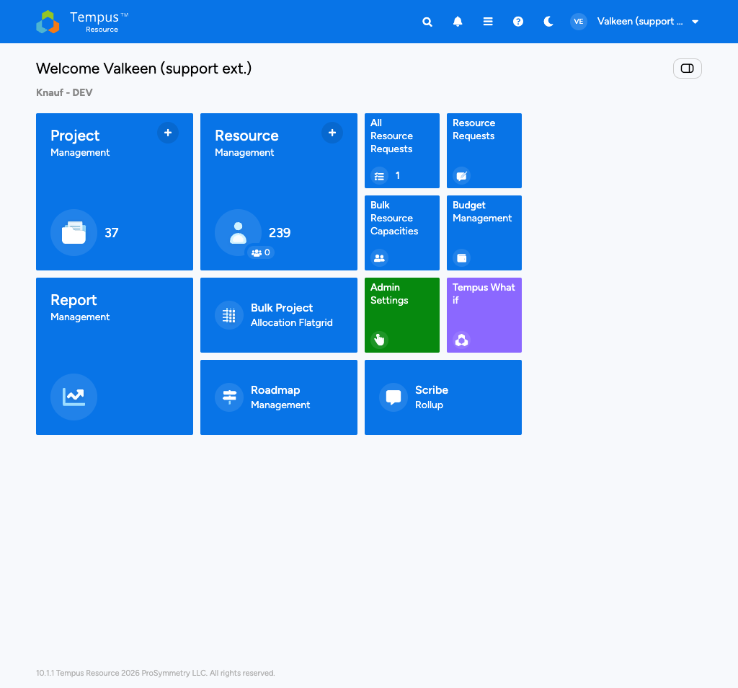
Knauf homescreen with tiles and Audit Log

How many tiles you see
Knauf controls which modules appear as tiles through Tempus global roles. The same physical person in sandbox and production may see different tiles if roles differ. Examples (not exhaustive, subject to Knauf configuration):
- PM/SM (planner): Often Project Management, Report Management, and project-deep links; Bulk Project Allocation Flatgrid and Budget Management may be off unless explicitly granted. Focus is single-project planning and master data.
- RM (planner): Often Resource Management, Bulk Project Allocation Flatgrid, resource request tiles, Bulk Resource Capacities; cross-project and capacity workflows. Project creation can be restricted depending on project role.
- Combined or admin-style test users (sandbox only): May show Admin Settings, Audit Log, Tempus What if, Scribe Rollup, and more — do not expect these in a pure PM/SM or RM production profile.

Tile reference (if shown for your login)
- Project Management - project repository; the + badge may open Create Project if you have rights.
- Resource Management - resource repository.
- Report Management - reports and dashboards.
- Bulk Project Allocation Flatgrid - multi-project allocation grid (often RM; see that chapter).
- Roadmap Management - roadmap / portfolio timeline (if licensed and granted).
- All Resource Requests / Resource Requests - request inbox and workflow.
- Bulk Resource Capacities - capacity editing at scale (often RM).
- Budget Management - budget rollups (if granted).
- Admin Settings - configuration (admin).
- Tempus What if - scenarios (separate governance).
- Scribe Rollup - rollup views (if granted).
- Audit Log - activity stream (only with audit permission).
Note: Note: If your homescreen looks “empty” compared to a colleague’s, that is usually role-based, not a defect.

Audit Log
The right-hand pane shows recent platform activity such as recent logins and project updates. It is read-only and helps you spot what other Knauf users have changed without leaving the homescreen.

Task Bar
The blue ribbon across the top is available from every screen:
- The Tempus logo (top-left) returns you to the homescreen.
- The magnifying glass opens global search to find a project, resource, or report.
- The bell opens notifications.
- The hamburger menu opens the full navigation drawer.
- The question mark opens the Help Center.
- The moon / sun icon toggles dark mode.
- The user avatar opens the profile menu (Profile, Subscriptions, My skill matrix, Logout).

Recommended Notification Subscriptions
Planners (PM/SM and RM) should configure notifications from the Subscriptions entry in the profile menu where your role allows it.

Project Notifications
In the Project tab, add the projects you want to follow. Avoid the "all projects" option, since each entry must be unsubscribed individually.
Recommended notifications per project:
- Attributes - any change to project attributes.
- Allocations - any change to project allocations.
- Deleted - notification when the project is deleted.

Resource Request Notifications
In the Resource Request tab, opt in to one or more outcomes for the resource requests you have submitted (approved, replaced, rejected, etc.).

Creating a Project
A new project is created from the Project Management grid. Once it has a name and a valid date range, you can immediately move on to defining master data, resources, and costs.

Open the Project Management Grid
From the homescreen, click the Project Management tile (or the small "+" badge on the tile for a shortcut into the create flow).
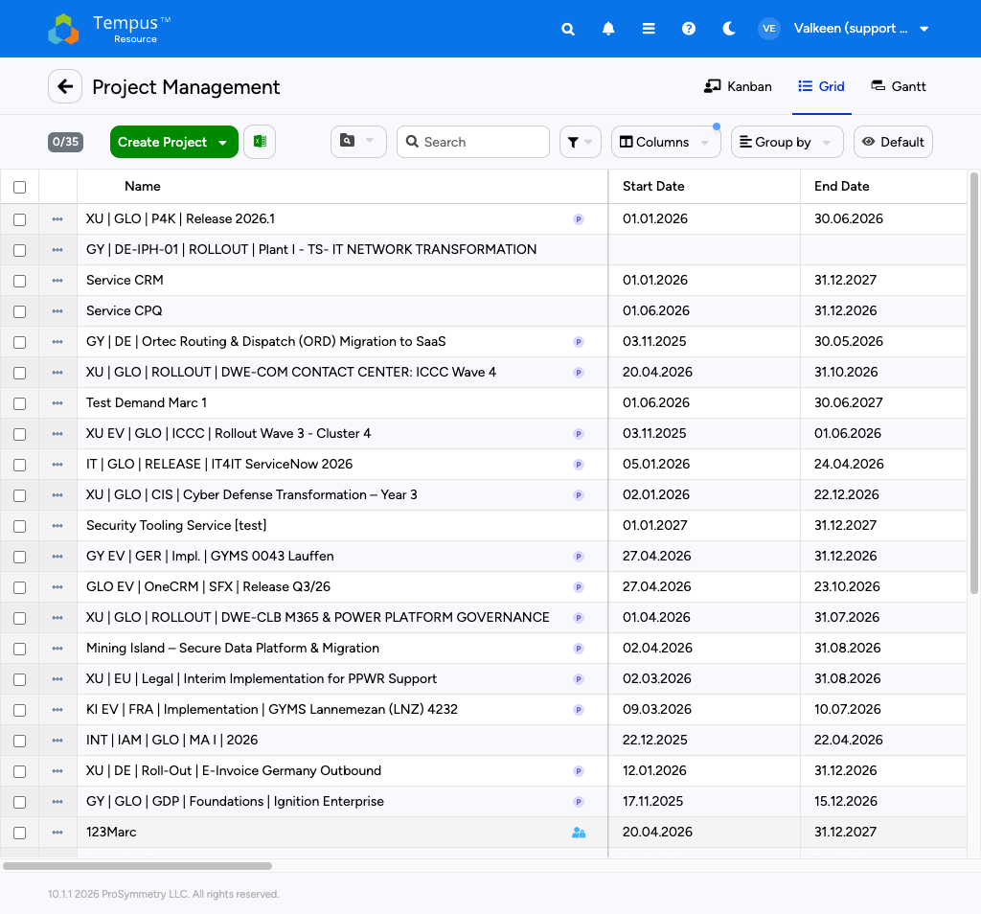
Project Management grid
The grid lists every project you can access. You can switch between Kanban, Grid, and Gantt view via the tabs in the top-right. Knauf naming follows a pipe-separated convention (for example XU | GLO | P4K | Release 2026.1), so the Search field with "contains" semantics is the fastest way to find a project.

Pick a Template
In the Project Management grid, click the green Create Project button. A dropdown opens with the templates that Knauf has configured. Phase 1 typically offers:
- Regular Project - the standard delivery template (tasks, allocations, financials).
- New Service - a Service template for recurring operational work; pre-populates a longer timeframe and the Service type.
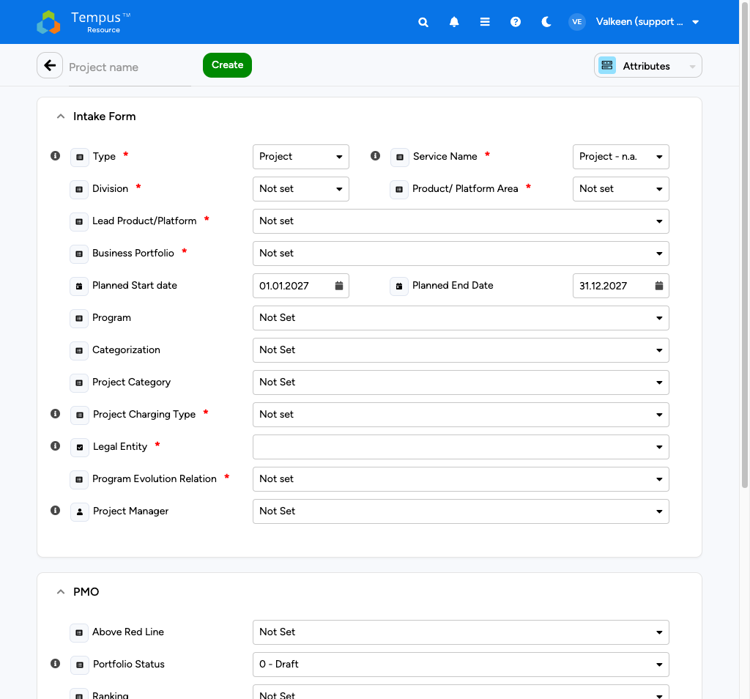
Create Project dropdown with Knauf templates
Pick the template that matches the work. The new project opens directly in its Attributes view so you can fill in the intake form.
Note: Note: Always start from a template rather than from a blank project. Templates carry Knauf's default attribute tagging and reduce setup time.

Fill In the Intake Form
The Attributes view of a new project is organised in three sections (Intake Form, PMO, System Fields). At minimum, populate the fields marked with a red asterisk:
- Project Name - unique and descriptive.
- Type - Project or Service.
- Service Name - applicable when Type is Service; pick a service category.
- Division - Knauf division responsible for the work.
- Product/Platform Area - the area (for example MSS, MoB).
- Lead Product/Platform - the leading platform (for example SFX Platform).
- Business Portfolio - the business portfolio this project belongs to (for example MoB).
- Planned Start date / Planned End Date - the project's planning window. Tempus uses this to drive the allocation and financial grids.
- Project Charging Type - how the project is charged internally.
- Legal Entity - the Knauf legal entity.
- Program Evolution Relation - the relationship to a parent program.
- Project Manager - the responsible PM. The PM sees the project under the "My Projects" quick filter.
The optional fields (Program, Categorization, Project Category) help with portfolio reporting later on but are not required to save the project.
Press Save in the top toolbar. Tempus persists the project and unlocks the other project views (Allocations, Financials, Schedule, etc.).

PMO and System Fields
After the intake form, scroll down to maintain the PMO information:
- Above Red Line - portfolio prioritisation flag.
- Portfolio Status - lifecycle status (default 0 - Draft).
- Ranking - portfolio ranking.
- Ext. Project Number - the external project number; tagged UNIQUE, so duplicates are rejected.
- Project Identifier Code (WBS) - the Knauf WBS code, for example A.0248.10.000460.22.
System Fields hold the Security Group (defaults to Default) and the Assignment Workflow; only adjust these when an admin has briefed you.

Project Master Data
Project master data lives in the Attributes view of the individual project screen. Keeping it accurate is the basis for clean filtering, grouping, and reporting later on.

Open the Attributes View
- From the Project Management grid, click any project name. The project opens in its default view.
- From the view selector in the top-right of the project screen, choose Attributes.
The Attributes view is grouped into four collapsible sections.
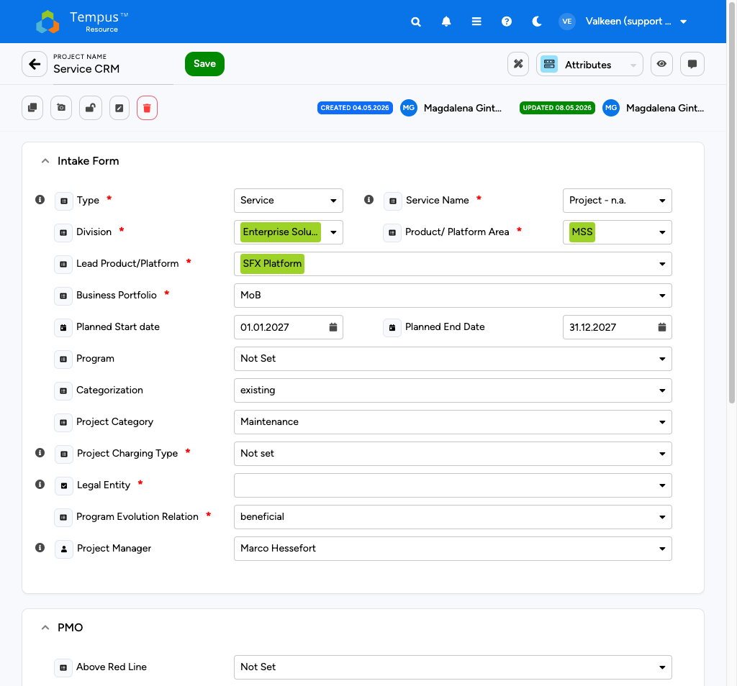
Project Attributes view

Intake Form
The Intake Form holds the core business attributes. The fields marked with a red asterisk are mandatory at Knauf.
- Type *: Project or Service.
- Service Name *: applicable when Type is Service; pick a service category. For regular projects this stays at Project - n.a..
- Division *: for example Enterprise Solutions.
- Product/ Platform Area *: for example MSS.
- Lead Product/Platform *: for example SFX Platform.
- Business Portfolio *: for example MoB.
- Planned Start date / Planned End Date: drives the allocation and financial timelines.
- Program: optional - links the project to a parent program.
- Categorization: optional - existing or new business.
- Project Category: optional - for example Maintenance.
- Project Charging Type *: how the project is charged internally.
- Legal Entity *: the responsible Knauf legal entity.
- Program Evolution Relation *: relation to the wider program portfolio (for example beneficial).
- Project Manager: the Tempus user owning the project end-to-end.
Note: Note: The green highlights you see around some attribute values are visual indicators that Knauf has configured. They typically flag attribute combinations that are valid or recommended.

PMO
The PMO section captures portfolio-level metadata used by Knauf's portfolio reporting:
- Above Red Line - prioritisation flag (Yes / No / Not Set).
- Portfolio Status - lifecycle status, starting at 0 - Draft for a new project.
- Ranking - portfolio ranking.
- Ext. Project Number - the external project number; tagged UNIQUE.
- Project Identifier Code (WBS) - the Knauf WBS code (for example A.0248.10.000460.22).

Dependency Section
Use the Dependency Section to point at predecessor and successor projects. Leave it as Please select... if there are no dependencies.

System Fields
System Fields are mostly read-only or admin-managed:
- ID - the internal Tempus project ID (read-only).
- Security Group - controls who can see and edit the project. Defaults to Default.
- Assignment Workflow - which approval workflow applies to resource requests; set by admin.

Editing Master Data
The Attributes view is editable in place. Adjust the values, then click Save in the top toolbar. There is no separate checkout step for the Attributes view at Knauf - changes are persisted directly.
If another user has the project locked, your edits will not save and you will see a warning. Wait for the lock to clear and retry.
Note: Note: Some attributes (Type, Service Name, Division, Portfolio fields) drive cost rollups and portfolio dashboards. Confirm with your Knauf admin which values are valid in your area, especially when creating a project from scratch.

Additional Project Options
Below the project name (top-left) you find a row of icons that expose power-user options:
- Clone - create a copy of the project, including allocations and attributes.
- Snapshot - capture the current state for later comparison.
- Lock / Unlock - prevent or allow concurrent edits.
- Create Template - turn the current project into a reusable template for future projects.
- Delete - remove the project (usually reserved for admins).

Additional project options buttons

Project vs. Service
Knauf plans two distinct kinds of work in Tempus: projects and services. They share the same allocation, master-data, and reporting screens, but Tempus distinguishes them through the Type attribute, which drives several downstream behaviours.

Templates at Creation Time
The distinction starts already in the Create Project dropdown. The Knauf templates available to you when your role allows project creation are typically:
- Regular Project - default template for delivery efforts with a defined goal, start, and end. Use this for transformation initiatives, rollouts, platform releases, and similar work.
- New Service - template for recurring operational work (run, change, maintenance, admin). The template pre-fills Type with Service and a longer default timeframe.
Note: Note: Pick the template at creation time; it pre-populates the attributes correctly. Changing Type later is possible but rarely needed and triggers a re-evaluation of cost and workflow logic.


Create Project template selector

Where the Difference Surfaces
Once created, both projects and services live side-by-side in the Project Management grid. Knauf typically prefixes services in the project name (for example Service CRM, Service CPQ) to make them easy to spot.
The Attributes view shows the difference explicitly:
- For projects, Type is Project and Service Name is Project - n.a..
- For services, Type is Service and Service Name carries the service category.

Decision Aid
- The work has a defined start and end with a delivery target -> Regular Project.
- The work is operational, ongoing, and team-based -> Service.
- The work is pending approval or still a "what-if" scenario -> use Tempus What if (Phase 2) to model it.

Implications for Planning
Knauf Phase 1 (Budget) organisational rule: For the first year of operations, Knauf intends no resource planning on services in production workflows — focus resource and capacity planning on projects first; services remain relevant for master data, cost categories, and reporting alignment. (Training material and sandbox may still use service examples so you recognise screens.) Later phases may extend resource planning to services; follow announcements from IT Governance / Controlling.
Where Knauf enables planning for both types, the same screens apply (allocations, financials, reports) with different defaults:
- Timeframe: Services often use longer horizons in templates; projects follow delivery milestones.
- Granularity: Planning is typically in Mandays and in month or quarter buckets, depending on the grid.
- Cost rollup: Services typically map to “run-the-business” portfolios; projects to “change-the-business” where reports split by Type.
- Reporting: Portfolio reports may filter by Type; use attributes consistently so filters work.
Financial categories (Phase 1): Knauf tracks seven cost dimensions in the controlling model, including external consulting, IT licenses, IT leasing, managed IT services, other costs, CAPEX, and internal effort (via rates × person-days). Exact aggregation to financial types is defined in Knauf workshops and may evolve — use the Financials view and Controlling guidance for mandatory coding.

Resource Planning
Resource planning at Knauf happens primarily in the Allocations view of an individual project. That is the main surface for PM/SM planners who own a project. RM planners may use the same view when supporting a project, but often spend more time in the Bulk Project Allocation Flatgrid (see there). Bulk operations across multiple projects are covered in the Bulk Project Allocation Flatgrid section.

Open the Allocations View
From the Project Management grid, click any project name. From the view selector in the top-right of the project screen, choose Allocations.
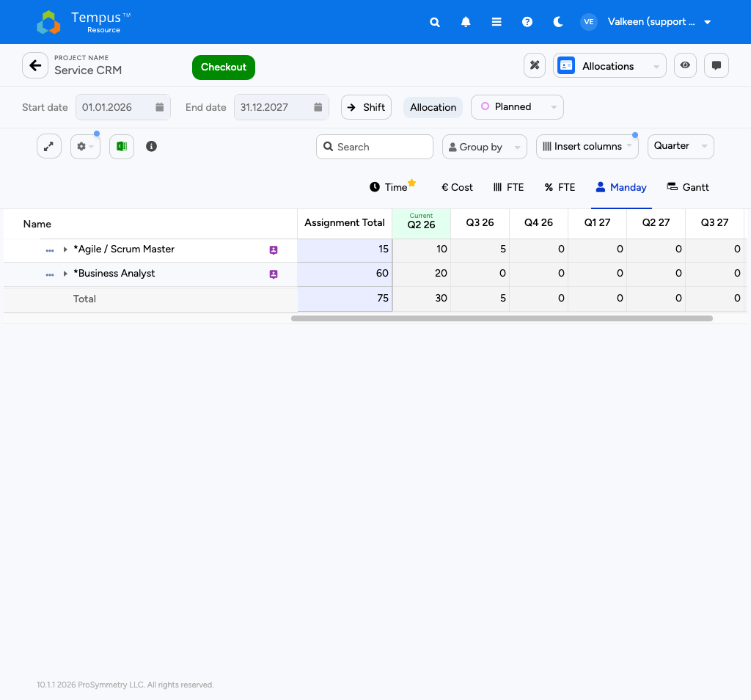
Single Project Allocations grid

Anatomy of the Grid
Above the grid you see the project metadata and toolbar:
- Project Name with the Checkout button. To edit anything (allocations, rates, costs) you must check the project out first.
- Start date and End date picker that limits the grid timeframe (read-only until you check out).
- Shift button to bulk-shift assignments by a number of months.
- Allocation toggle and Planned / Actual selector.
The toolbar below contains:
- Expand grid - one-click expansion of every group.
- Options (gear) - per-grid options (heatmap, totals, etc.).
- Excel export, info.
- Search, Group by, Insert columns.

Capacity Unit and Granularity
Knauf plans in Mandays (not Hours) and Quarterly buckets by default. You can switch via the tabs above the grid:
- Time - generic time unit.
- € Cost - the same grid expressed in Euro, calculated from the allocations and the resource rate.
- FTE - full-time equivalents.
- FTE % - percentage of capacity.
- Manday - the default Knauf unit.
- Gantt - timeline view.
Note: Note: Switching between Manday and € Cost re-renders the same allocation in different units, with no underlying data change. It is the fastest way to sanity-check planned cost against capacity.

Working with Allocations

Add a Resource (Demand-Planning Role)
Knauf typically books capacity against demand-planning resources first (recognisable by the * prefix in the resource name, for example *Agile / Scrum Master, *Business Analyst). To add one:
- Click Checkout to acquire the edit lock.
- Click into the empty row labelled Type a new resource and start typing the role name. The dropdown narrows as you type.
- Pick the role. A new row appears.

Add Multiple Resources / Tasks at Once
Use the ellipsis menu next to a resource or task name to open the Add Assignment dialog. Pick one or more resources on the left and one or more tasks on the right, then click Add to create all combinations.

Add a New Task
Scroll to the bottom of the task list to find the green row labelled Type a new Task. Enter the task name and confirm with Enter.

Enter Allocations
Type the planned Mandays per cell. Values can be copied, pasted, or click-and-dragged across the grid. To request additional capacity for a resource already on a project, enter the new total allocation in the cell (not the delta).

Save
Click Save and Check In in the top toolbar to persist the changes and trigger any resource requests, or Release to discard them.

Allocation grid in Manday view with demand-planning roles

Resource Request Workflow
Whenever you save an allocation change, Tempus creates a resource request that the responsible Resource Manager has to approve. The status icon to the left of the resource name shows where the request stands:
- Pending - awaiting approval.
- Approved - request approved (capacity is firm).
- Rejected - request rejected (revise or escalate).

Advanced Assignment Options
Click the ellipsis next to an assigned resource to open Assignment Options:
- Clone - duplicate the assignment to another start date, task, or resource.
- Shift - move the assignment to a new start date.

Cost Planning
At Knauf, costs in Tempus are split into two layers:
- Labor costs are derived automatically from the project's allocations multiplied by the applicable resource rate. They show up in the Allocations view (€ Cost tab) and in cost rollups.
- Non-labor costs (external consulting, software licenses, hardware, travel) are maintained explicitly in the project's Financials view.
This split keeps the resource plan and the financial plan in sync without double-booking.
Knauf’s controlling model distinguishes seven financial category families (for example external consulting, IT licenses, leasing, managed services, other, CAPEX, and internal effort via daily rates × PD). How they aggregate to portfolio reports is defined by Knauf workshops; use Type / OpEx / CapEx and Controlling instructions when you create lines.

Labor Cost in the Allocations View
In the Allocations view, switch to the € Cost tab to see the same allocations expressed in Euro. The grid mirrors the Manday view cell-for-cell; the only difference is the unit.
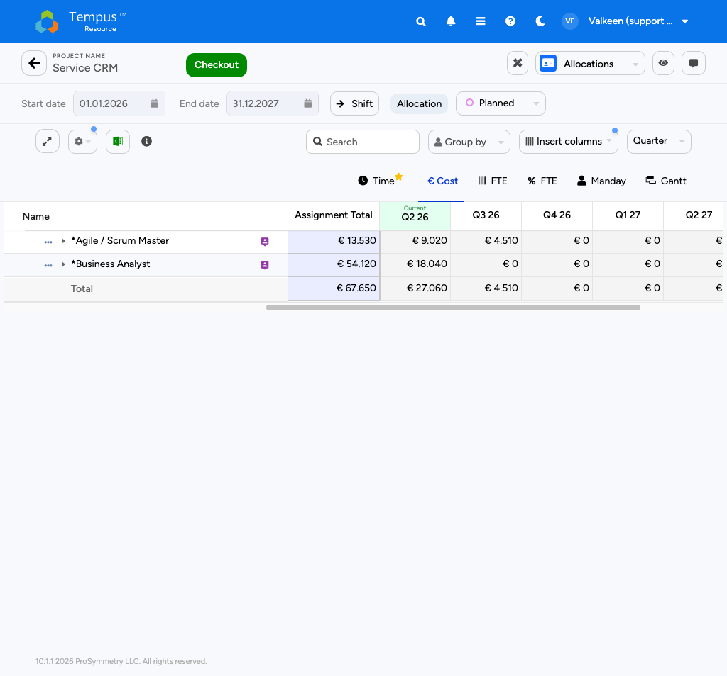
Allocations grid in Cost (Euro) view
The total at the bottom of the grid gives you the planned labor cost for the project across the selected timeframe.
Note: Note: The € numbers update whenever you change an allocation or whenever a Knauf admin updates the rate definition. They should be considered a derived value, not an input.

Non-Labor Cost in the Financials View
For everything that is not labor, open the Financials view from the view selector. The grid lets you maintain planned and actual cost line items.
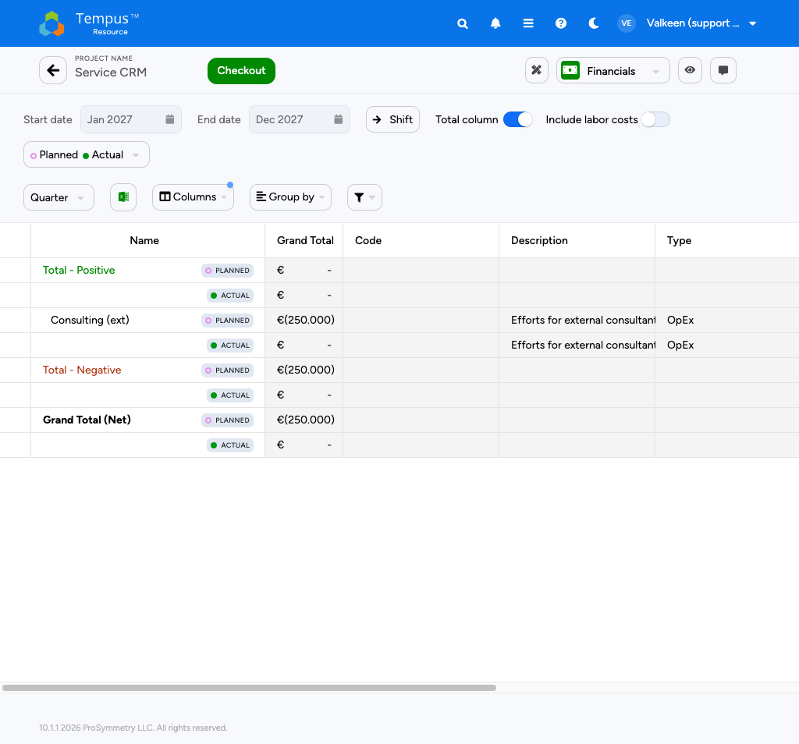
Financials view with planned and actual cost lines

Anatomy of the Financials Grid
- Start / End date restrict the timeframe of the grid.
- Planned / Actual toggle decides which series is editable.
- Total column toggle adds a grand total column.
- Include labor costs toggle pulls labor cost (from Allocations) into the grid so you see the full picture in one place. Keep it off when you only want to plan non-labor items.
- Quarter / Group by / Insert columns / Filter work the same as in the Allocations view.

Grid Columns
Each row represents a cost line and carries:
- Name - free text label, for example Consulting (ext).
- Planned / Actual indicator on the right side of the name.
- Grand Total - sum across the timeframe.
- Code - cost code (optional).
- Description - free text.
- Type - cost classification (OpEx, CapEx).
The bottom of the grid shows three roll-up rows:
- Total - Positive - revenue / positive entries.
- Total - Negative - costs / negative entries (typically the dominant line for Knauf projects).
- Grand Total (Net) - net result.

Adding a Cost Line
- Check the project out from the Allocations view (the lock is shared).
- Switch to the Financials view.
- Add a new line via the toolbar action, fill in Name, Description, Type, and the cost value in the relevant time bucket.
- Save the project.

Cost Rollup to the Portfolio
When several Knauf projects roll into a program or portfolio, Tempus aggregates planned costs across the hierarchy. Labor and non-labor costs follow their own configured roll-up paths. The portfolio-level result is what you see in the Budget Management tile and in the financial portfolio reports.
Note: Note: Confirm with the Knauf controller which cost types (OpEx vs. CapEx) and which charging type apply in your area. The downstream reporting groups by these attributes, so consistent tagging matters.

Bulk Project Allocation Flatgrid
The Bulk Project Allocation Flatgrid (BPA Flatgrid) is the tool for editing allocations across many projects in one grid. In Knauf’s role model it is typically assigned to Resource Managers (RM); PM/SM profiles often use the single-project Allocations view instead unless Knauf has explicitly granted BPA. If you do not see the Bulk Project Allocation Flatgrid tile, assume your global role does not include it and speak to your Tempus owner.
Open it from the homescreen by clicking the Bulk Project Allocation Flatgrid tile when that tile is visible.
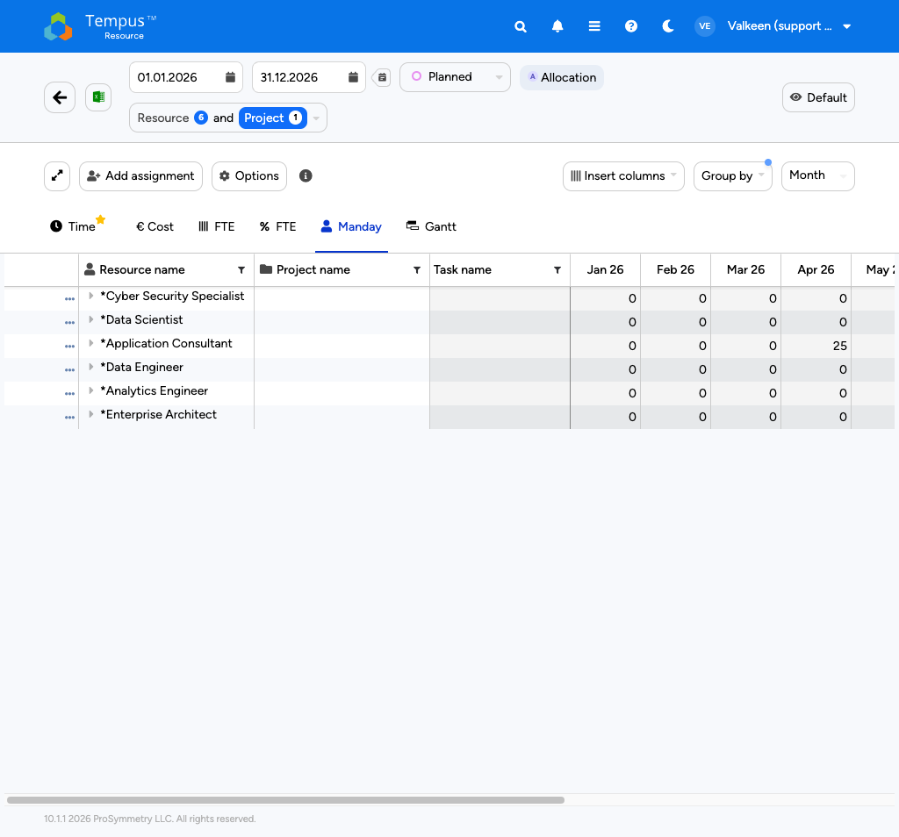
BPA Flatgrid overview

Grid Overview
- The project timeframe sits in the top-left and is editable via the date picker. A small calendar icon next to the end date offers quick-pick timeframes.
- The Planned / Actual toggle and the Allocation / Assignment toggle control what is editable.
- The Resource and Project selector in the centre supports three modes:
- Project - select projects; their resources are auto-loaded.
- Resource - select resources; the projects they are on are auto-loaded.
- Default - free choice; useful for adding allocations to resources not yet on a project. The numeric badges next to Resource and Project show how many items are currently selected.
- The View Management dialog in the top-right (Default) lets you create, clone, lock, set-default, edit, or delete views.

Customisation Ribbon
Above the grid you find:
- Expand grid - one-click expansion.
- Add assignment - create a new Resource-Project-Task combination on the fly.
- Options - heatmaps, totals, filters (see below).
- Insert columns - add project, resource, or assignment attribute columns.
- Group by - any project, resource, or assignment attribute.
- Time granularity dropdown - typically Month at Knauf for BPA Flatgrid usage.
The unit tabs above the grid (Time, € Cost, FTE, FTE %, Manday, Gantt) work identically to the Single Project Allocation view. Most Knauf PMs work in Manday.

Options Menu
The Options menu adds advanced controls:
- Overlay Heatmap - Resource Heatmap, Resource Request Heatmap, or Non-Zero Heatmap.
- Hide Task - drop the task column when not needed.
- Show Total Row at every aggregation level.
- Show Total Demand Planning / Show Named Total - totals on generic vs. named resources.
- Show Unallocated % - share of assignments still to be redistributed from generic to named resources.
- Show Selection Calculations - average / sum / min / max / count for the selected cells.
- Tasks to Show - generic (project-level) vs. non-generic (custom tasks).
- Weekly Display Format - week number, start date, or end date.
- Filter by Resource Request Status - filter to pending, approved, or rejected requests.

A Working Pattern for Knauf PMs
- Switch the mode selector to Project and pick the projects you are responsible for. The BPA Flatgrid pre-loads the assigned resources.
- Confirm the timeframe matches your reporting window.
- Insert the columns you care about (Business Portfolio, Type, Project Manager, etc.).
- Group by the right attribute (for example by Project) so that totals roll up the way you want to look at them.
- If you find yourself recreating the same setup repeatedly, save it as a personal view.
Note: Note: Public views are administratively defined and read-only. Clone the public view first, then work in the copy.

Updating Existing Assignments
- Click into the cell and edit the value.
- Click Save at the top of the grid. Tempus creates a new resource request for the change automatically.

Adding New Assignments
- Click Add Assignment.
- Pick a project, resource, and task. Tick Allow new Resources to add a resource not yet on the project. Use Add new Task to introduce a task on the fly.
- Click Add new assignment to confirm.
- A new row appears. Enter the allocation values.
- Click Save to persist the changes.

Reviewing Pending Resource Requests
In the Options menu open the Filter by Resource Request Status dropdown and tick Pending. The grid filters down to only the requests still awaiting a Resource Manager response.

Reporting Basics
Reporting at Knauf is concentrated in the Report Management tile on the homescreen. From there you reach the full report list, plus the seven standard report types Knauf has configured.
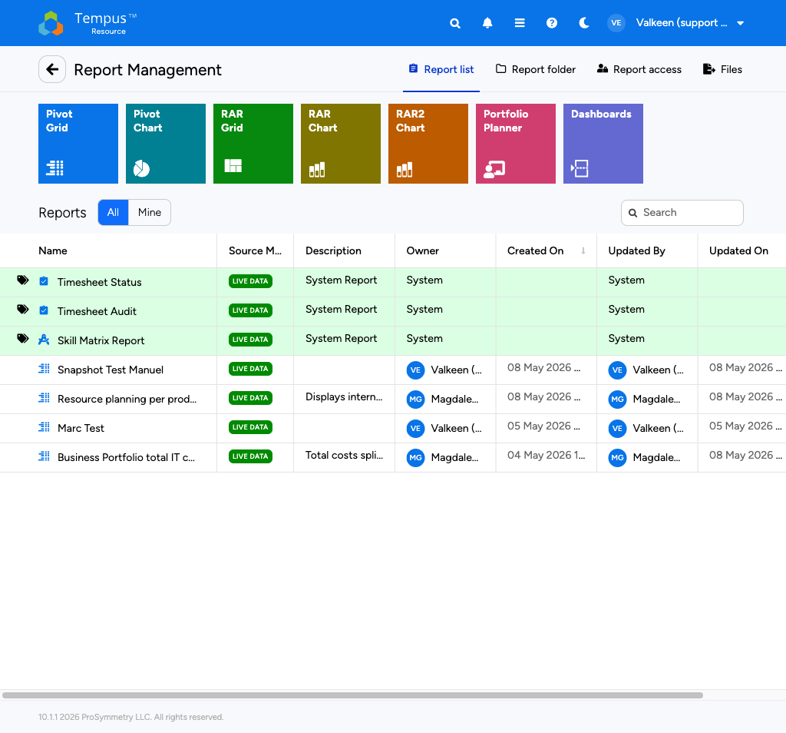
Report Management with report types and Knauf reports

Report Types
The colourful tiles at the top of the Report Management screen let you create new reports from a fixed set of layouts:
- Pivot Grid - tabular pivot.
- Pivot Chart - pivot rendered as a chart.
- RAR Grid - Resource Allocation Report in grid form.
- RAR Chart - Resource Allocation Report as chart.
- RAR2 Chart - alternative RAR chart variant.
- Portfolio Planner - portfolio-level planning report.
- Dashboards - composite dashboards combining several charts and tables.
Planners (PM/SM and RM) typically consume reports created by Controlling or PPM rather than author new layouts. The tiles are still useful because they show which report family you get when someone shares a link with you.

Report List
Below the tiles is the report list with two quick filters:
- All - all reports you have viewer access to.
- Mine - only the reports you own.
Each row shows the report name, the source type (Knauf reports are tagged LIVE DATA), an optional description, the owner, and the creation / last update metadata. The icons at the far right let you clone or delete (for owners).
Note: Note: Report access is controlled per role. If a report you need is missing, ask the Knauf Tempus admin to grant viewer rights.

Reports You Will Likely Use
Some of the recurring Knauf-managed reports include:
- Timesheet Status and Timesheet Audit - operational reports for managers tracking submission status.
- Skill Matrix Report - capability overview across the resource pool.
- Resource planning per product / platform - capacity overview by product area.
- Business Portfolio total IT cost - portfolio cost rollup, useful for steering committees.
Click any report to open it. Inside the report you have filters at the top, an export menu (Excel / CSV / PDF), and - depending on the report type - drill-down on chart segments.

Other Tabs
The top-right tabs of the Report Management screen are:
- Report list - the default landing tab (see above).
- Report folder - folders Knauf admins use to organise reports.
- Report access - manage who can view individual reports (owners only).
- Files - file attachments related to reports.

Subscribing to Report Updates
Where Knauf has enabled it, you can schedule recurring email delivery of a report from inside the report. This is typically used for weekly portfolio summaries.
Note: Note: Phase 1 focuses on consuming the existing reports. Dashboard creation, custom report design, and Insight+ deeper analytics are Phase 2 topics and not covered in this guide.

